Inter Thread Communication:

- Two threads communicating with each other by using (wait, notify, notifyall)

Who has to call wait()?
- A thread which is expecting update, has to call wait() and immediately the thread entered into waiting state.
Who has to call notify()?
- A thread which is responsible to perform update, after performing update and it has to call notify(), then the waiting thread will get the notification and continue its execution with those updated items.

All above methods are present in Object class Why?
start(), join() are required by only threads and they are applicable only for threads so they are present in thread class. But wait(), notify(), notifyall() are present in Object class but not in Thread class because thread can call these methods on any java objects like Student Class, post box class, Customer Class and it can be any objects. So these methods are required by any java objects.

Above methods are only useful in multithreading, then why it is present in Object class instead of Thread class?
- Thread can call these methods on any java objects.

If a thread wants to call wait, notify notifyall methods on any object, then compulsory this thread should be owner of that
Object otherwise jvm throws IllegalMonitorException. Owner in the sense, the thread should have the lock of that object that is the thread should be in synchrozied area.

So we call wait, notify notifyall methods only in synchrozied area else it throws runtime exception called IllegalMonitorException.

A thread get lock on Object ob and calls wait (). A thread can get many locks but related to object ob it should be only one.
After calling wait() on object ob and it immediately releases the lock on that particular object only and immediately entered into waiting state.

Why the thread releases the lock after calling wait() immediately?
- The reason it immediately releases the lock is - some updating thread has to update the waiting object by acquiring the lock. If it doesn’t releases the lock then the updating thread cant update the object ob without acquiring the lock.

Thread notify:
Some threads do update and notify, some other do notify and update, both are possible based on developer.
If a thread calls notify() on object ob, it releases the lock of the object ob but may not immediately because after notify, it may do any updation.
Except wait, notify,notifyall there is no other methods where thread (join, yeild,sleep) releases the lock.

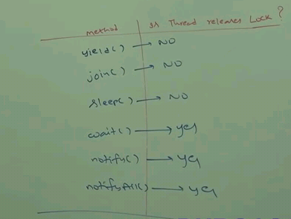

Methods:
public final void wait() throws InterrupedException- until getting notification it wait
public final native void wait(long milii) throws InterrupedException - not implemented in java, implemented in os level
public final void wait(long milii, int nano) throws InterrupedException

public final native notify()
public final native notifyAll()

Note: In above methods, every wait() throws InterrupedException which is checked exception because only a waiting thread can be interrupted. Whenever we are using, compulsory we should handle InterrupedException either by try/catch or throws keyword.
Notify() need not to go in waiting state so it doesn’t have InterrupedException.

- after notify, the notifying thread will continue, there is no waiting state

When the waiting thread come out of waiting state and entered into another waiting state?
1) Waiting thread got notification
2) Waiting time expires
3) Waiting thread interrupted

For all above 3 scenarios, the waiting thread goes to another waiting state in order to get lock on the notified object or object ob. after getting the lock on the object ob then only it entered into Ready/Runnable state. After entering into Ready state there is no guarantee that it enter into running state. That is entirely depends on Thread Scheduler which will schedule the threads based on scheduling algorithm to allocate the processor.

When a waiting thread got notification or waiting time expires or waiting thread interrupted, then which state it go?
- The waiting thread goes to another waiting thread to get the lock of object to continue execution.

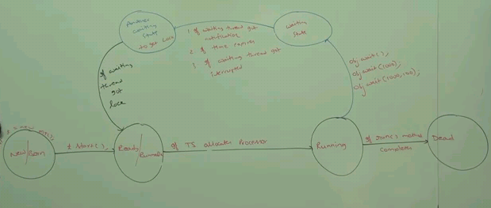

Summary:
- Two threads communicate each other by using wait, notify, notifyall
- wait, notify, notifyall methods are present in Object class but not Thread class
- wait, notify, notifyall methods we have to call only from synchronized area otherwise throws illegal monitor exception
- If a thread calls wait(), immediately thread release the lock and entered into waiting state
- If a thread calls notify(), it releases the lock but may not immediately
- wait, notify, notifyall methods are the only methods where thread releases the lock so that notifying thread can update the waiting thread.

Example:
In below program, main thread expecting some updation (updated total value)
Here we cannot expect the correct total value in main thread because if main thread got chance we get 0, if child thread got chance and completed total then we get 5050. If child got chance and in intermediate main thread got chance then we get some other intermediate value b/w 0 to 5050.
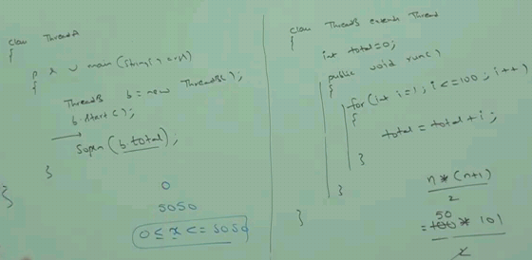

In order to get the updation (updated total value) in main thread, we can use join() by making b.join() in main thread which gives correct total value. Because calling b.join() in main thread makes the currently executing thread to wait until completing b. So we get the updated value. But this is not recommended because calling join() makes the main thread to wait until completing thread b. Thread object b may any no of lines to execute after completing the for loop. We need the update immediately after performing the loop but not to wait until completing all other lines after the loop. Because at the end of the loop itself we can get the updated value instead of waiting to get at the end.

In such cases, we need to go for wait().
- If a thread t1 wants to wait until completing t2 because the output of t2 thread may be needed for the thread t1 and hence t1 has to call t2.join().

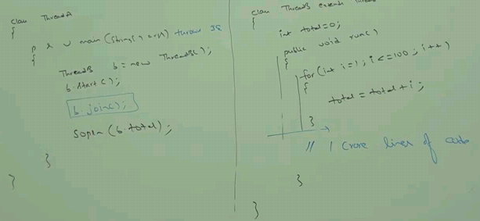

Above program using Wait() and notify():
In below program, after calling wait(), the main thread releases the lock and enter into waiting state. The child thread after executing the loop, it call the notify() to the waiting thread.
This program throws illegal monitor exception because wait(), notify(), notifyAll() should be used in synchronized area only.

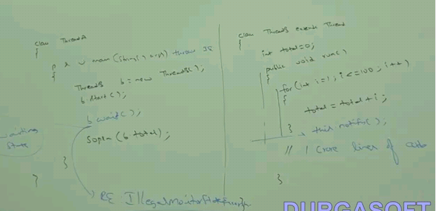

Modify above program using wait() and notify():
Here main thread wait infinitely until it is notified by someone. Consider if child thread got the chance to execute first, then calling notify() is not going to use here because main thread still not entered into waiting state by calling the wait(). The child thread executed first and called notify(), then main thread execute the wait() and go in waiting state. There is no one to notify here because notify was called before main thread go to waiting state. So the main thread should be in waiting state infinitely. In order to avoid this, use wait() with milleseconds arguments to wait for speficic period of time only.

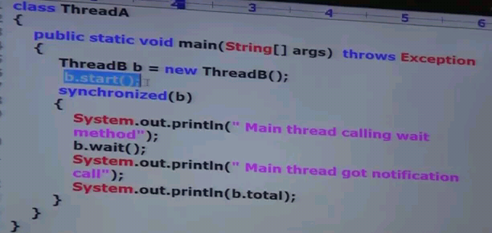
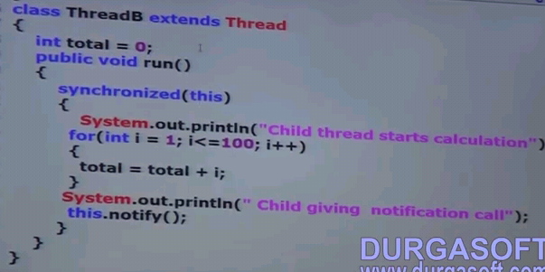
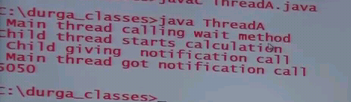

Example: Consumer - Producer example:
Producer thread is responsible to produce items to the queue.
Consumer thread is responsible to consume items from the queue.
Queue is the common java object b/w producer and consumer threads.
If queue is empty, then consumer thread will call wait() on queue object and entered into waiting state and also releases the lock on queue object.
After producing items to the queue, producer thread is responsible to call notify().
Then the waiting consumer will get the notification and continue its execution with updated items.

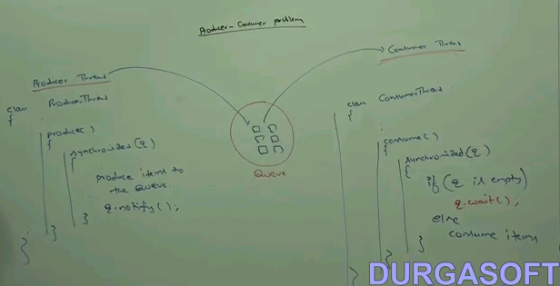

Diff b/w notify and notifyAll():
If 10 waiting consumer threads are waiting for the queue object updation, then notifyAll() will be called by producer thread instead of calling 10 times of notify().
if the producer call notify() to give the notification to multiple waiting threads- then only one thread got notified and remaining threads have to wait for further notification. Which thread will be notified, we cant expect. It depends on JVM.

So The producer call notify() to give the notification to only one waiting thread - notify()
So the producer call notifyAll() to give the notification to multiple waiting threads - notifyAll()

We can use notifyAll() to give the notification for all waiting threads of a particular object. Eventhough multiple threads are notified but execution will be performed one by one because threads are required to get the lock on that particular object. Since only one lock is available, the threads acquire lock sequentially and executes.

